**OUTREACH SCHOOLS EXAMINATION BOARD**

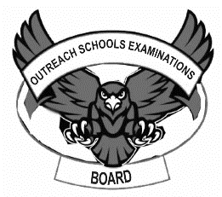**BEGINNING OF TERM III EXAMINATION 2023**

**BABY CLASS: (3 – 4 YEARS)**

**LEARNING AREA 3: HEALTH HABITS**

**My name is: ……………………………………………………………….**

**My School is: …………………………………….………………………..**

**I am in: ………………………………..…………………………….…………………..**

1. **Match things with a good smell.**

D:\BECKY\images\kibuuka pic\ice cream 2.jpg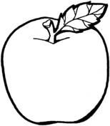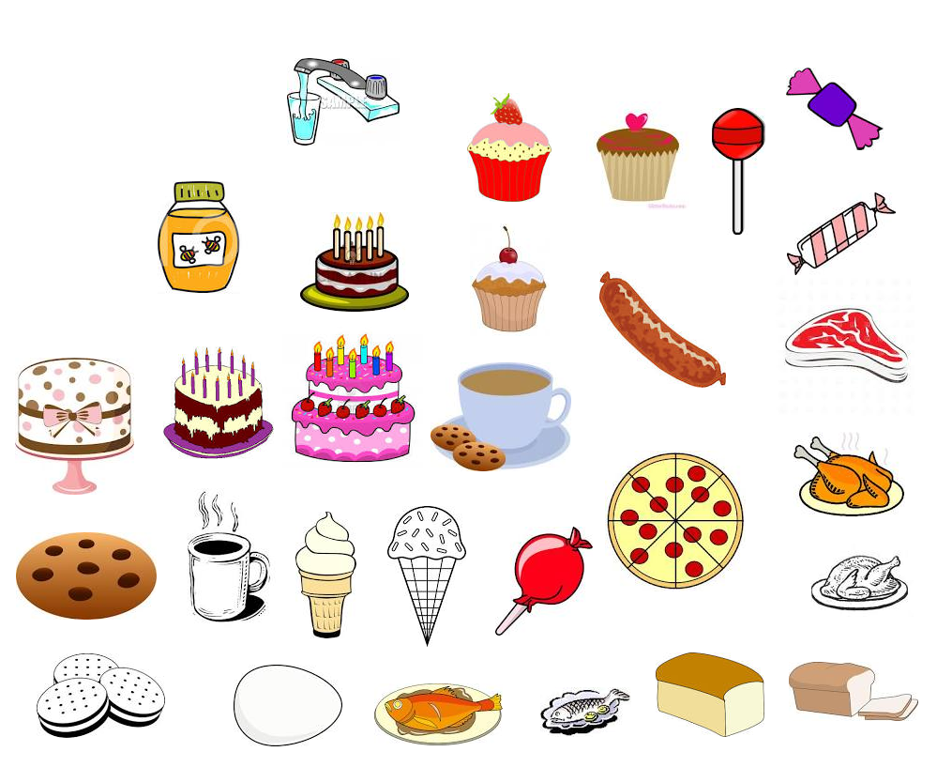

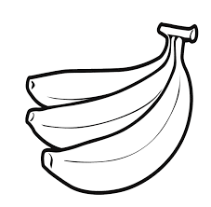

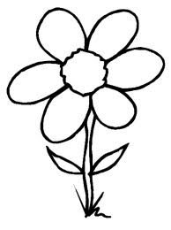



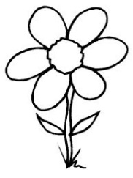D:\BECKY\images\kibuuka pic\ice cream 2.jpg

1. **Trace the parts of the mouth.**

teeth

lips

tongue

1. **Match and colour the same things we use to clean our homes.**

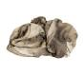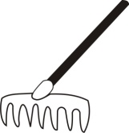

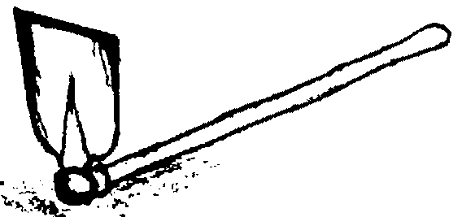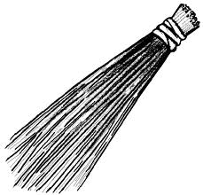



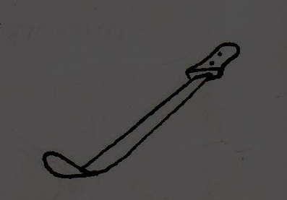



1. 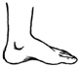**Circle the same body parts.**

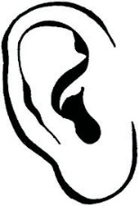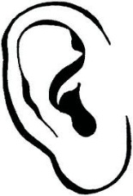

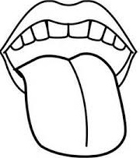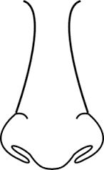

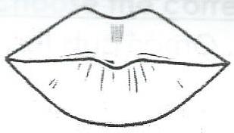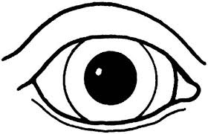

1. **Shade your leg.**

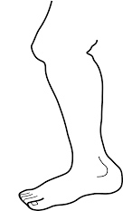

**End**